HSDC January 22 Premier Project Presentation: Gun Violence in the United States Analytics

## **A Project by Team KNN**



# **INTRODUCTION**

The rise in lack of profitable employment world-wide among many other things has catalysed the bane of gun violence amidst young people. A comprehensive data that has been compiled from 2013- 2018 guarantees some insight into this problem. In this analysis we derived insights from the data and did some predictive analysis.

# **AIMS AND OBJECTIVES**

The aim of this project is to analyze the data to determine the frequency of occurrences across the various states in the country, the age distribution of the victims and participants in the violent activities, common places of occurrences and gender status of participants.

# **FLOW PROCESS**

* Data sourcing
* Data preparation
* Data visualization

**Data sourcing**: This has to do with sourcing of the data. Dataset for this project is obtained from Kaggle , available at <https://www.kaggle.com/jameslko/gun-violence-data> .The dataset is comprised of 34 columns and 239678 incidents.

**Data Preparation**: This has to do with wrangling, cleaning and imputing of missing data. Its also involves exploratory analysis in order to derive insights. The data for the project was derived as two .csv files, these files were concatenated to form one working file. The null values in the dataset were ignored due to the negligible percentage compared to the available values. An occurrence which wasn’t added to the dataset was manually added. The date column was split into year, month, month day and weekday. The ‘n_killed’ and ‘n_injured’ column were also combined to give a ‘violence’ column.

**Data Visualization**: The columns were plotted using different tools. A bar plot was used to visualize the distribution of incidence by year, month and day. Word cloud was used to determine the frequencies of the violence by place.

## **INSIGHTS FROM THE DATA**

***Number of Gun violence per Year***

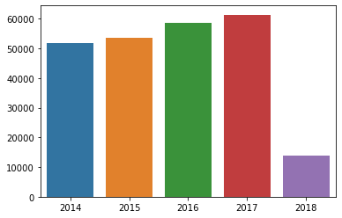

From the bar plot, the gun violence activities were seen to be rising with year, the year 2018 has data from only 3 months, so this year can be ignored.

***Incidence per Month***

**Average Incident per Year** 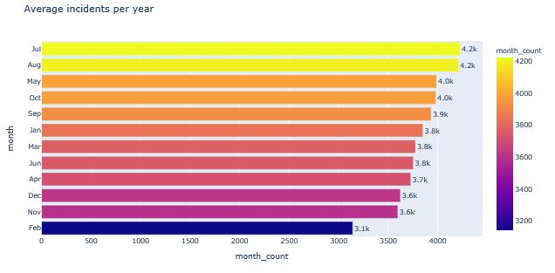

From the bar plots, the months of July and August had the most incidents of Gun violence. January, August, March, July are the most violent months. Why are these months the most violent? we can observe a peak around July every year from 2014 to 2017.

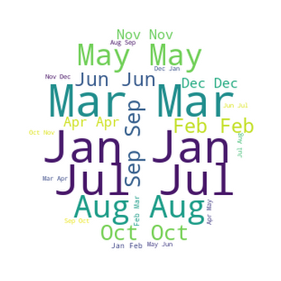

The word cloud show months of prevalence as January, July, August and March.

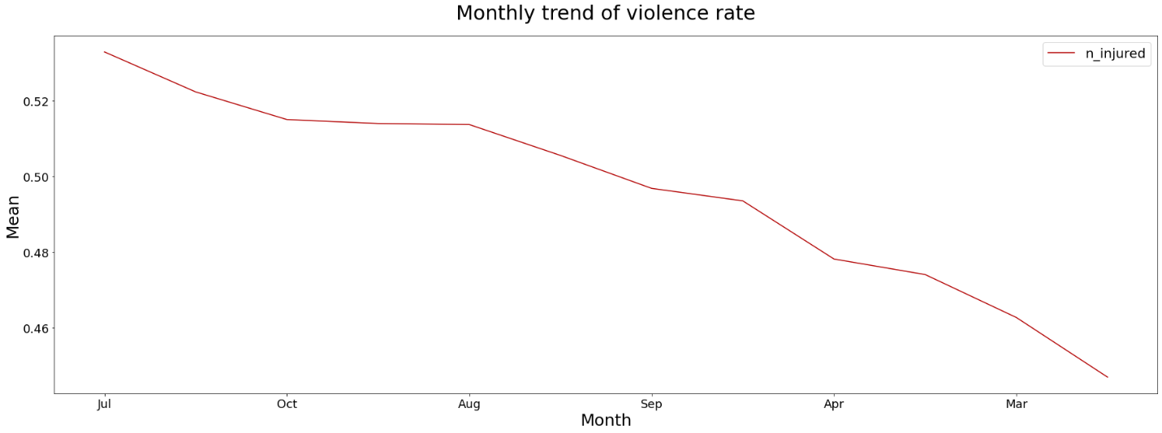

A monthly trend shows prevalence of violence rate by month of July.

***AVERAGE INCIDENCE PER DAY OF THE WEEK***

This analyses to gain insight on which of the days of the week did most gun violence occur

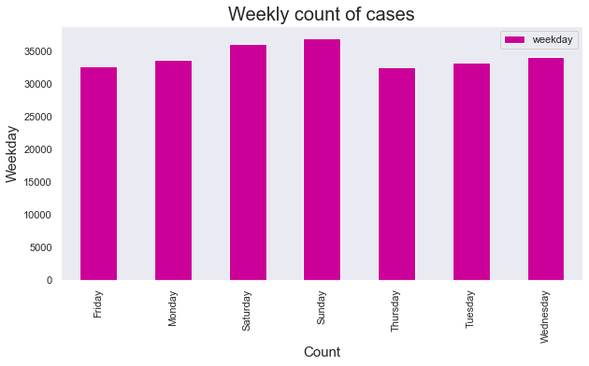



Both the bar plots and word cloud show a peak of incidence by midweek and weekends. Most gun violence took place on Sundays, Saturdays and Wednesdays.

***COMMON AREAS OF INCIDENCE***

This seeks to derive the most common place where gun violent activities took place. Using the location description of occurrence of violence to find areas of most occurrence.

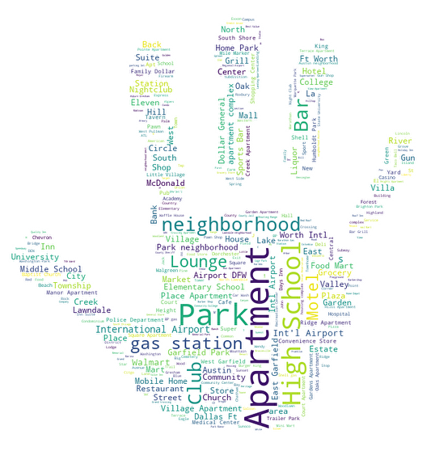

From the word cloud, it indicates most gun incidents took place at personal apartments, clubs, gas station and parks.

**Number of incidents by State**

This would seek to find the most violent State using the number of incidences

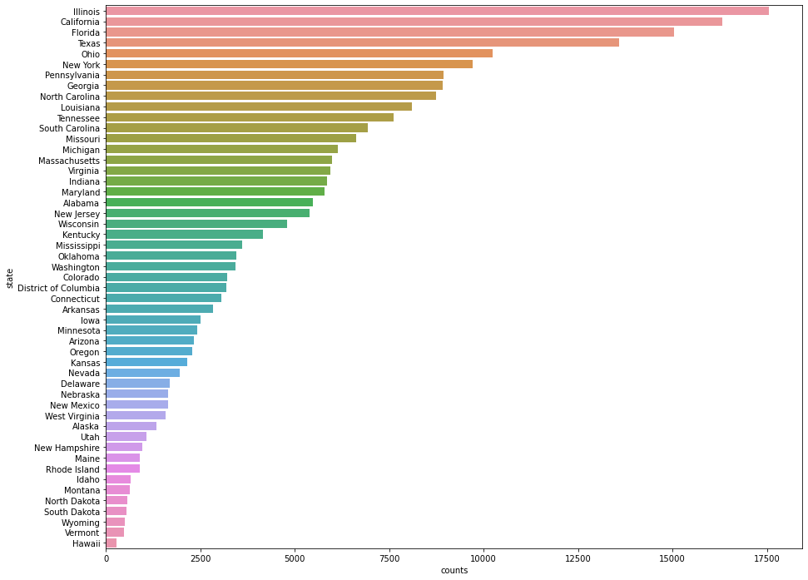

Illinois represents the most violent state with the highest number of incidents.

The most violent states in the entire US are as follows:

* **Illinois**
* **California**
* **Florida**
* **Texas**
* **Ohio**
* **New York**

**Population and Incident relationship per State**

Using the 2013 census report, we obtained the population of each of the states and analyzed the number of violence per 100k persons. This would identify the state that records the highest number of incidents according to population.

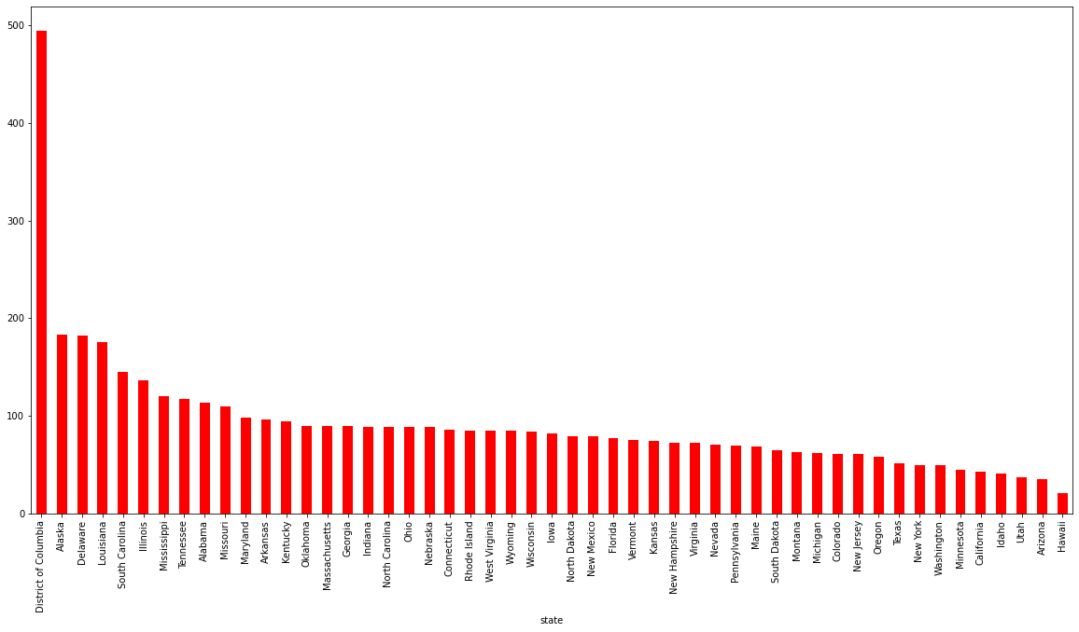

District of Columbia represents the state with highest incidence per 100k persons. Violence here maybe direct impact from population growth., while Arizona, Utah, and Idaho are the states with least number of incidents in population adjusted dataset.

**Participants type and gender**

This would determine the most violent gender prominent among the participants.

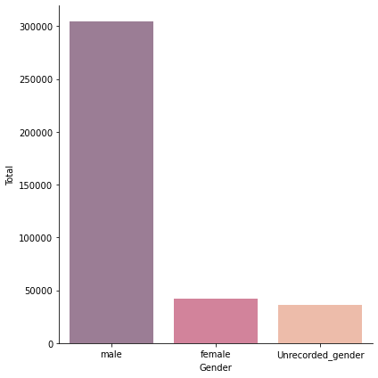

Here we can see that males are 6.5x more involves in the violence.

**Participants by Age**

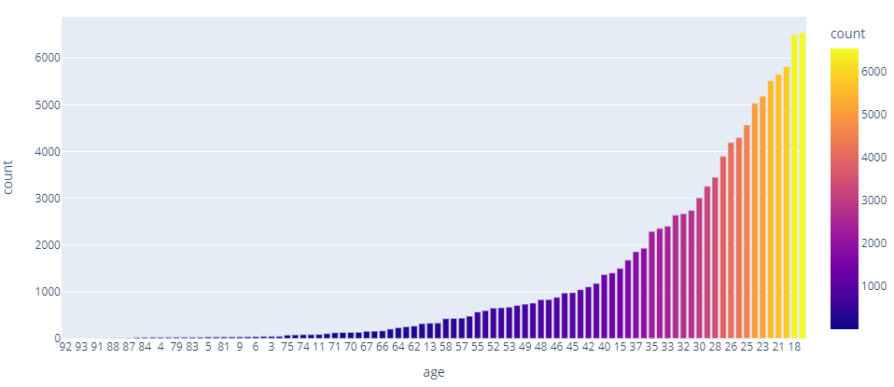

Most of the participants are aged 18,21,23,25 and 28. This represents the youthful age bracket. Reason for such a portion of this bracket could be related to unemployment which is most evident within this class.

**Age of Victims of violence**

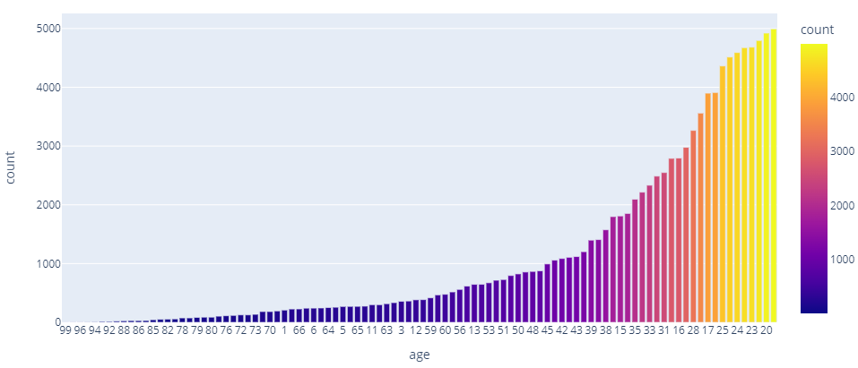

From indications the victims of these violence are also the same with that of the perpetrators. Overall, we can observe that most killings involved young except school shootings.

**Incident Characteristics**

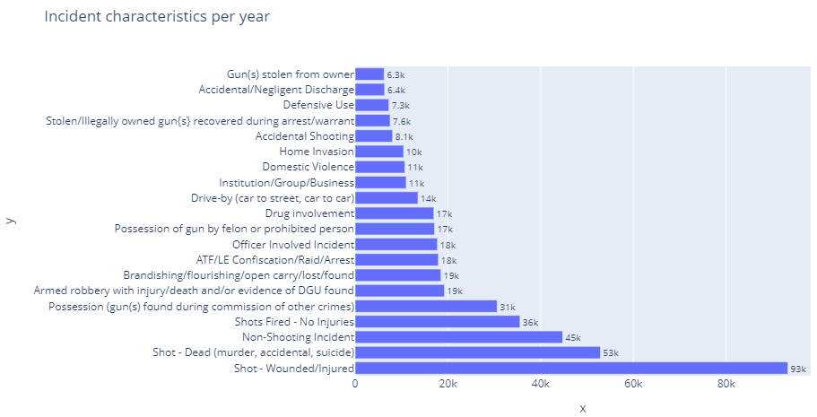

**Number of Guns used per state**

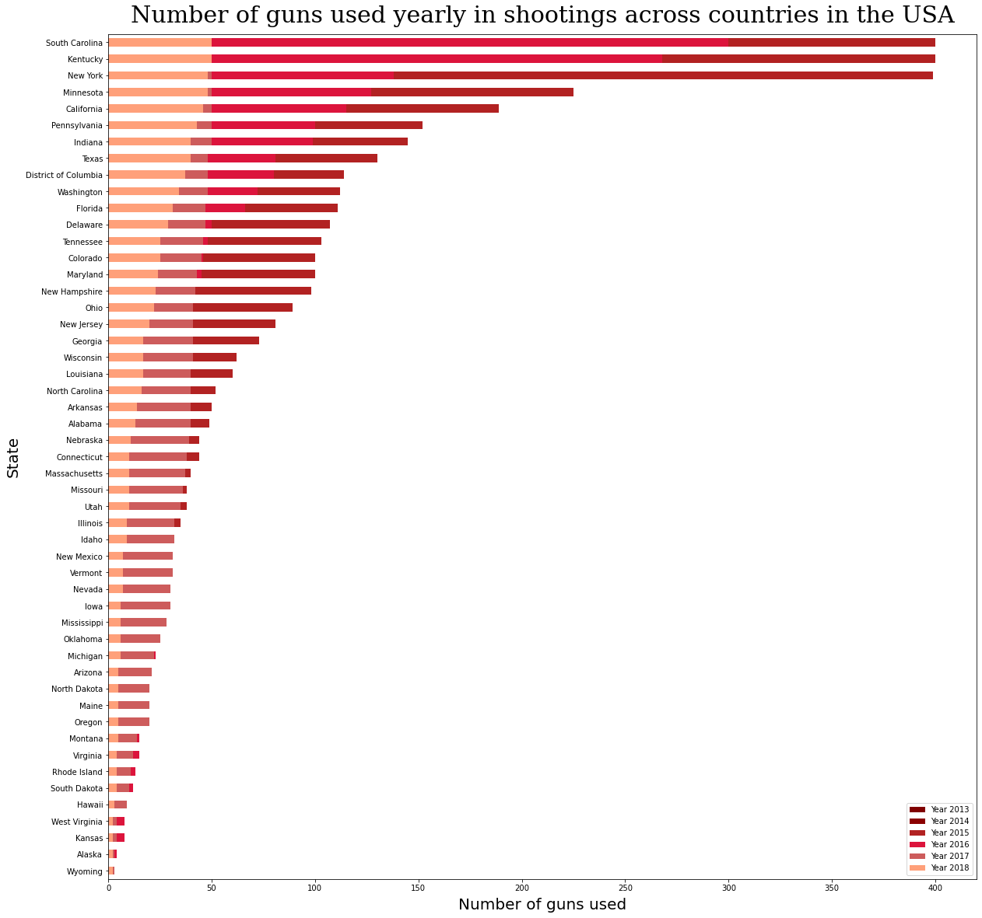

South Carolina, Kentucky and New York have Number of guns used yearly in shootings across the country.

**Total number of guns involved**

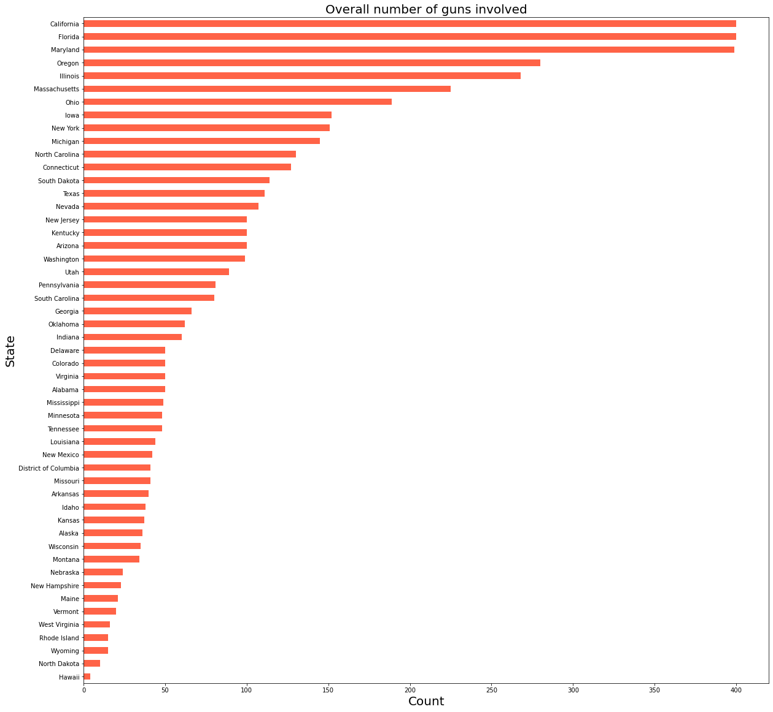

Hawaii presents a smaller number of guns; this might just be the reason it is safe for holidays.

**Conclusion**

* Gun violence activities have high occurrences during the weekends. This maybe related to the fact that most people are at home or out at leisure Park. This also confirms the analysis that gun violence activities mostly occur at personal apartments and Parks.
* More of the participants in gun violence are male.
* Illinois represents the most violent state.
* The month of July represent the most violent month and specifically a peak occurs between 4th and 5th July. This period coincidence with the National Holiday. It is presumable that the National Holiday has an effect on gun violence.
* The age bracket of participants and victims in this violence are between 18 and 25. These age group represents the population of the country most hit by unemployment. Therefore, unemployment can be regarded as one of the causes of rising gun violence.
* There is a high portion of the participants as male. Which suggest that a gun violence incident is more likely to be a male.
* There should be increased security vigilance during the holidays and weekends.
* Unemployment is a major cause of the gun violence activities, an increase in profitable employment can reduce the rate of violence.

**Team Members**

* Akshay Satpute (Project Lead)
* Ibukun Ekunwe
* Ashiyanbi Omotolani (Assistant Project Lead)
* Favour Ojiaku
* Rahmat Alimi
* Jebet Cherogony
* Saoban Lateefat
* Sandra Ozohili
* Chinonso Emmanuel Onodi
* Deborah Kolade
* Emek Udoh
* Damilola Olubobokun
* Joseph Ubeh
* Enyeneobong Akpan (Query Analyst)
* Vincent Odogwu
* Kaine Karibi-George
* Stephanie Anyanwu
* Michael Kehinde Oladosu
* Grace Aidoo
* Osagie Peter